Download maven dependencies to a specific directory.

1. Using mvn command -- mvn dependency:copy-dependencies -DoutputDirectory=./Mydependencies

mvn dependency:copy-dependencies --> e command maven build lo estea default ga ani jars target folder lo copy aavutai.

mvn dependency:copy-dependencies -DoutputDirectory=./Mydependencies --> mana project lo "Mydependencies" anea folder create ie tarvata daniloki jars copy aavutai.

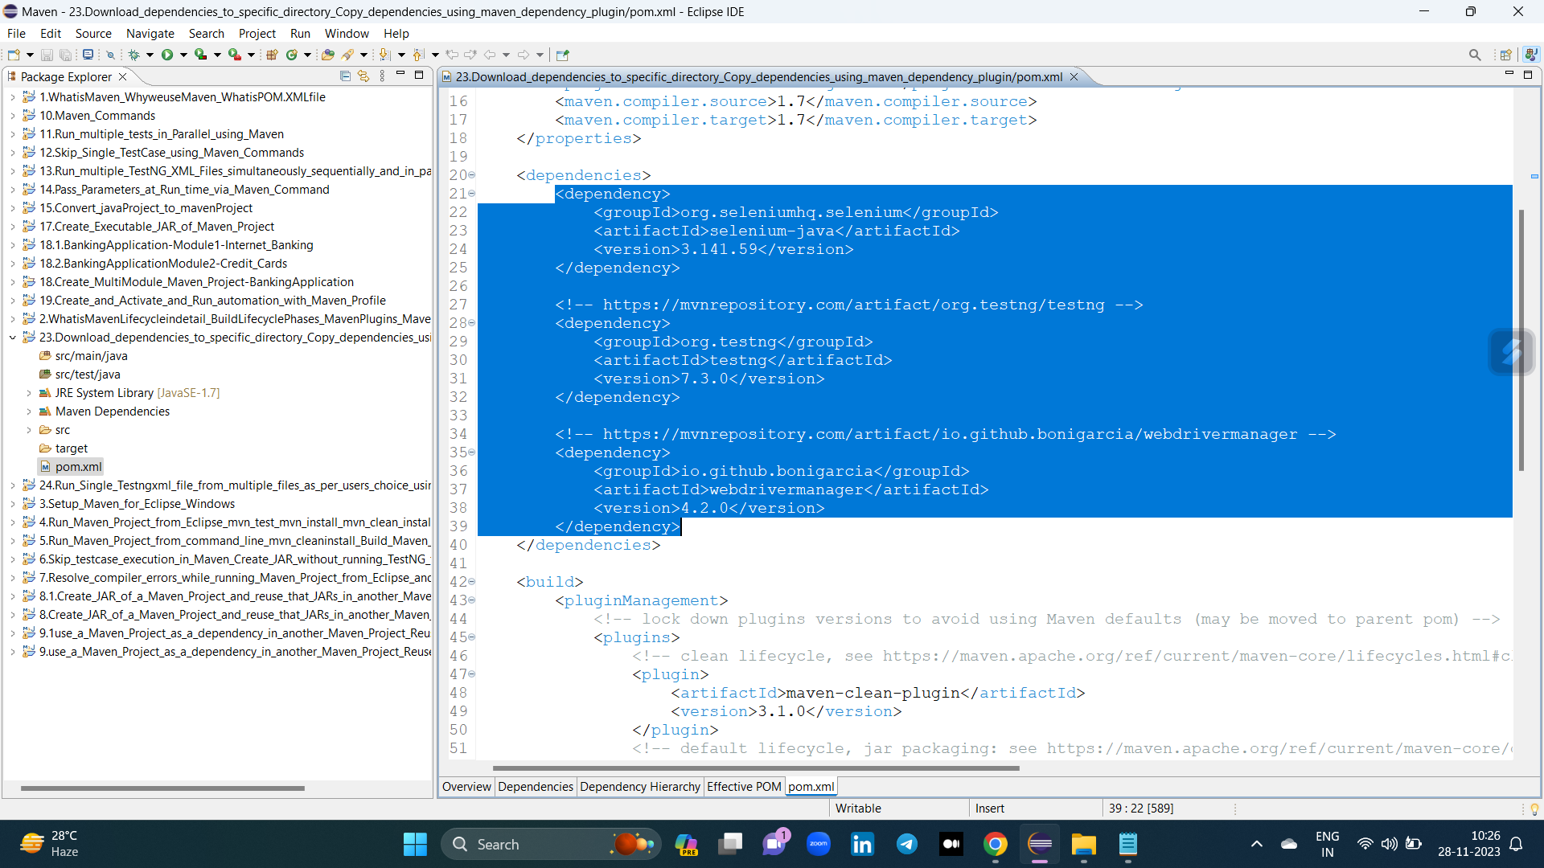

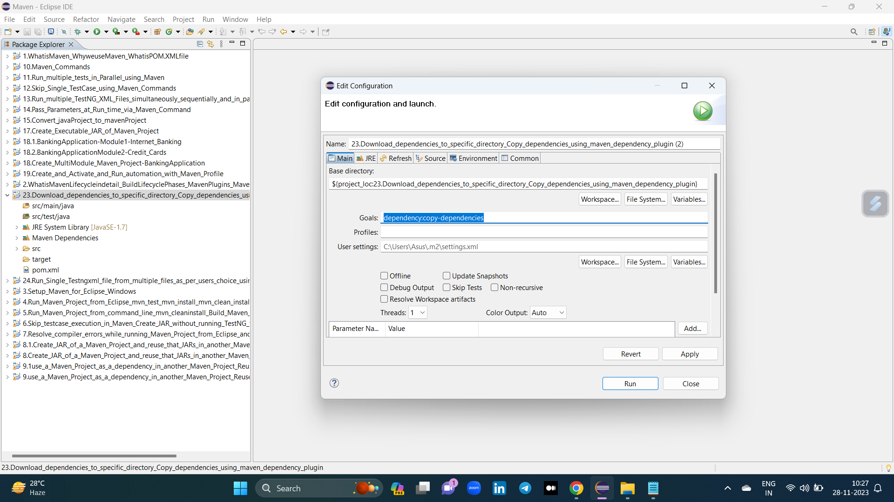

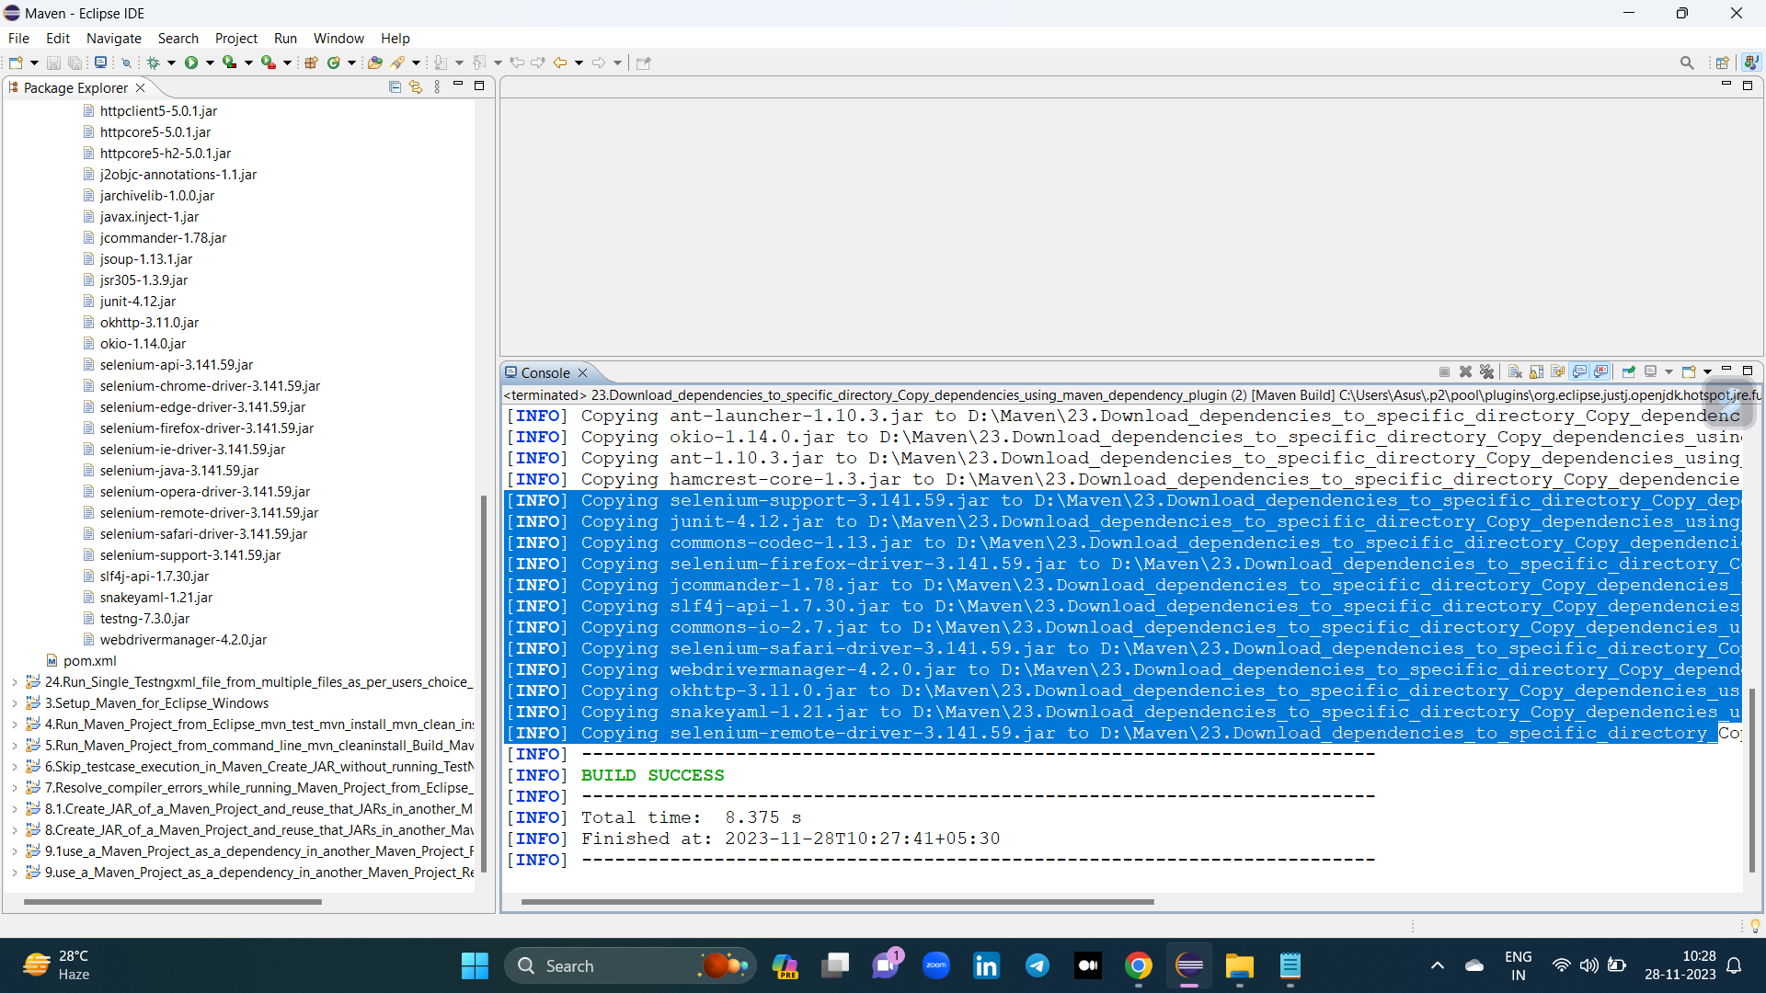

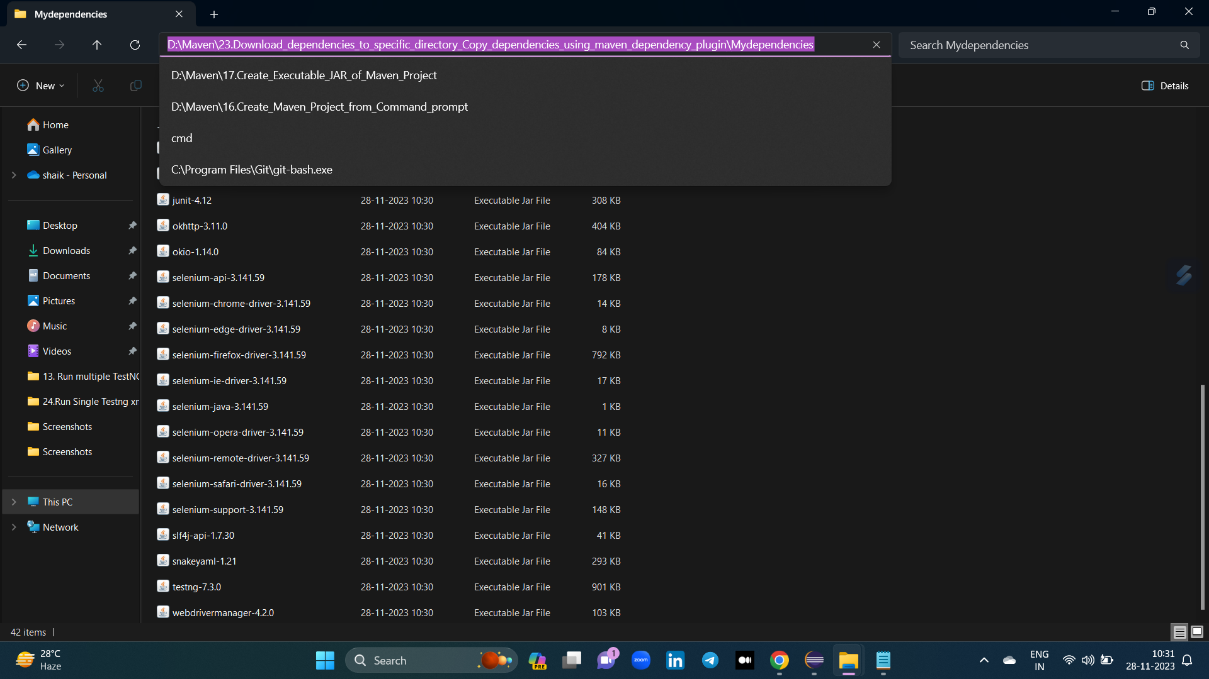

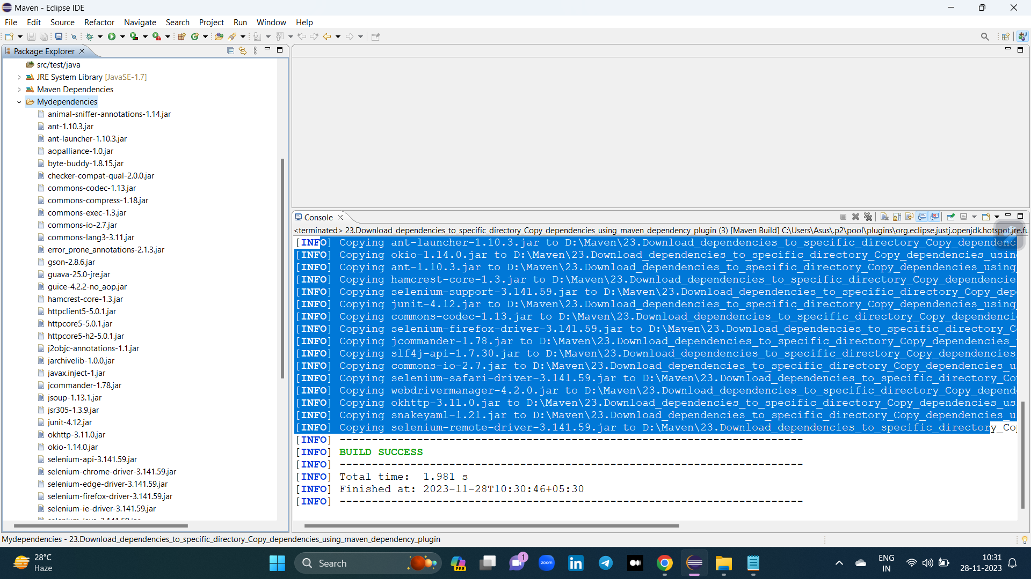

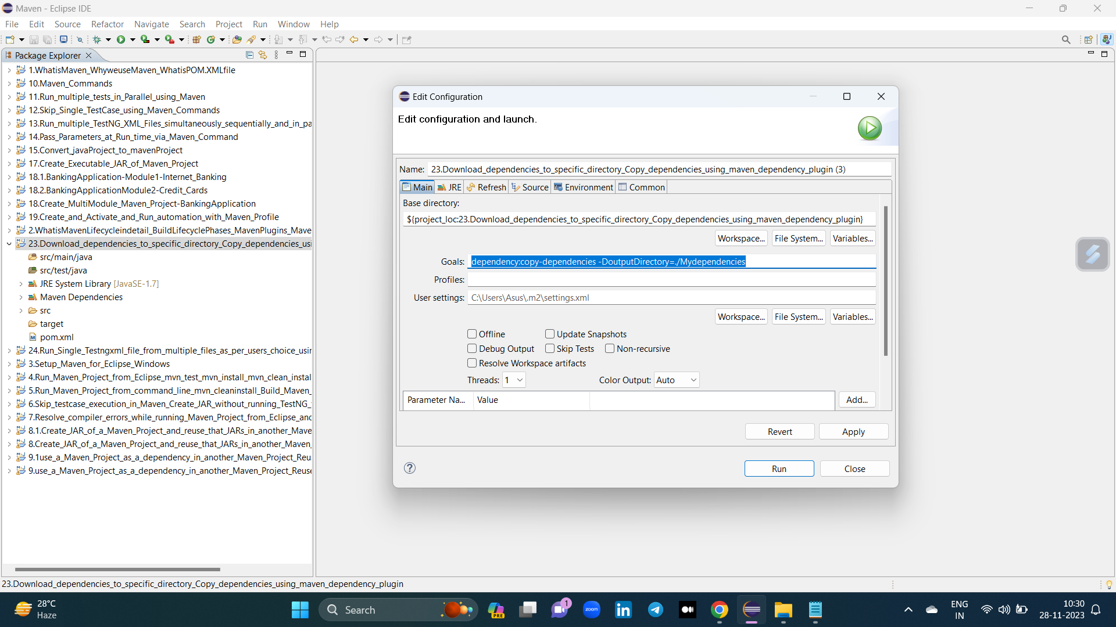

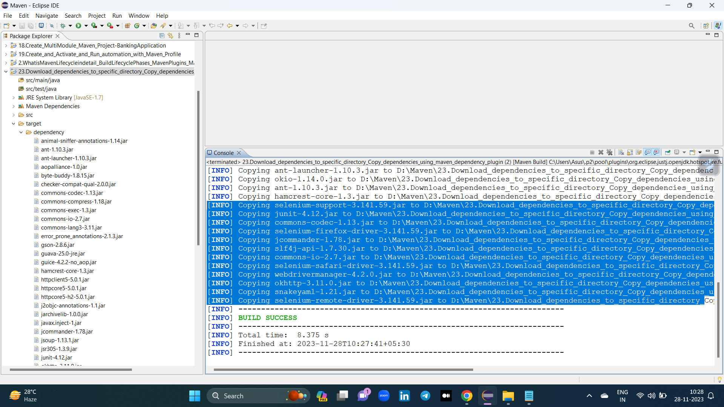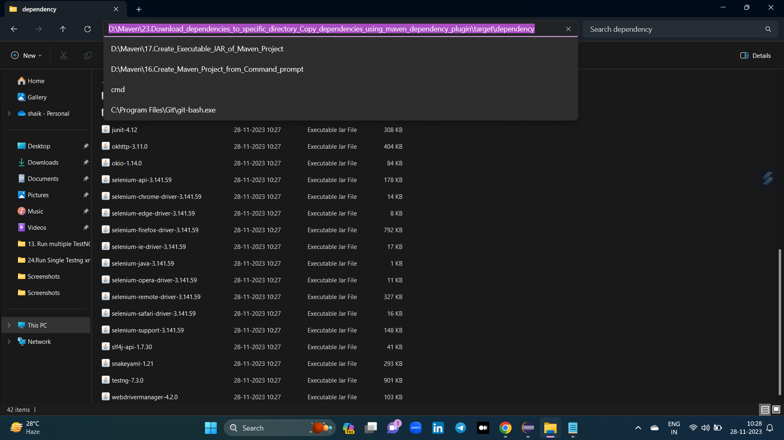

2. Using dependency Plugin - Add dependency plugin in pom.xml and save the file or just run the maven test/ verify command so that all the latest Jars would get downloaded to directory you have provided in the configuration. (not working present)

<plugin>

<groupId>org.apache.maven.plugins</groupId>

<artifactId>maven-dependency-plugin</artifactId>

<version>3.6.1</version>

<executions>

<execution>

<id>copy-dependencies</id>

<phase>package</phase>

<goals>

<goal>copy-dependencies</goal>

</goals>

<configuration>

<!-- other configurations here -->

</configuration>

</execution>

</executions>

</plugin>